**HTML**

* **Are the HTML tags and elements the same thing?**
* HTML tags come in pairs consisting opening tags and closing tags. However, some tags do not have a closing tags. HTML tags are called building blocks.
* HTML elements are components that are used in HTML Page. HTML elements include content in addition to op. tags and cl. Tags. So we can say that HTML tags and elements aren’t the same thing.

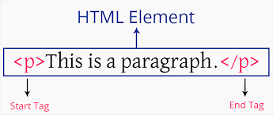

* **What are tags and attributes in HTML?**
* HTML tags are used to hold the HTML element. HTML tag starts with < and ends with >.
* To describe the characterisctic of an HTML element in detail attributes are used. Attributes modify how the elements behave.
* **What are void elements in HTML? With Example.**
* Those elements which have opening tags but don’t have closing tags are called void elements. They can’t hold the content

Ex. <br>, <hr>, <img>, <input>, etc.

* **What are HTML Entities? With Example.**
* HTML entities is text that starts with ampersand ( & ) and ends with a semicolon ( ; ).
* HTML entities are frequently used to show HTML code and invisible characters ( like spaces, different signs like less than ( < ), greater than ( > ), etc. ).

Ex. &nbsp; &lt; &gt; etc.

* **What are different types of lists in HTML? With Example.**
* There are main three types of lists and they are Ordered lists, Unordered lists & Description lists.
* Ordered lists consist of Alphabets ( A & a both ), Numericals ( 1 ) & Roman numbers ( I & i both ).Its tags are <ol> & <li>.
* Unordered lists consist of symbols like circle, disc, square, etc. Its tags are <ul> & <li>.
* Description list is a list of terms, which shows description of each term. Its tags are <dl>, <dt> & <dd>. Where <dl> defines description list, <dt> defines name term & <dd> tag defines each term.

Ex.

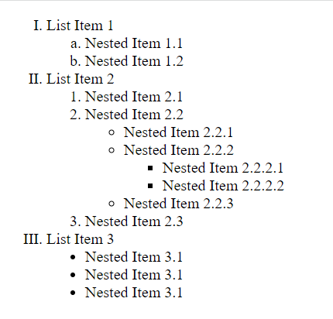

* **What is the ‘class’ attribute in HTML? With Example.**
* Class attribute is used to specify an element. It can also be used to manipulate the specific element through style sheet.
* A single class name can be used in multiple elements and any element. And also a single element can be given multiple class names.

Ex.

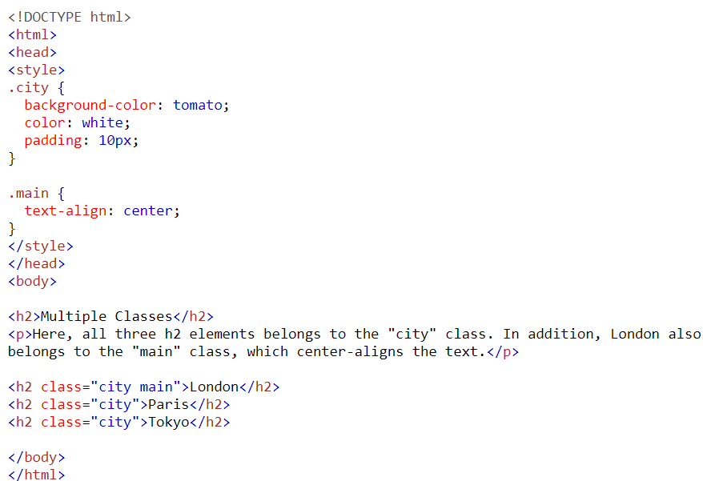

Result can be shown below:

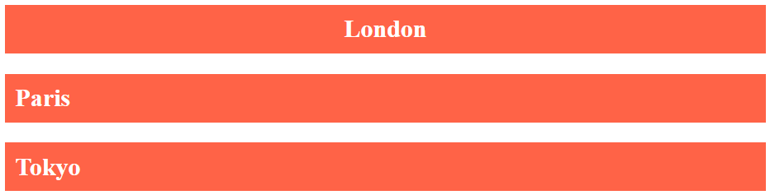

* **What is the difference between the ‘id’ attribute and the ‘class’ attribute of HTML elements? With Example.**
* ‘Id’ attribute and ‘class’ attribute are both used to spacify and manipulate the elements. But a class name can be used by multiple elements, while an id name must only be used by one element.
* In style sheet syntax of class name starts from period ( . ), while syntax of id name starts feom hash ( # ).

Ex.

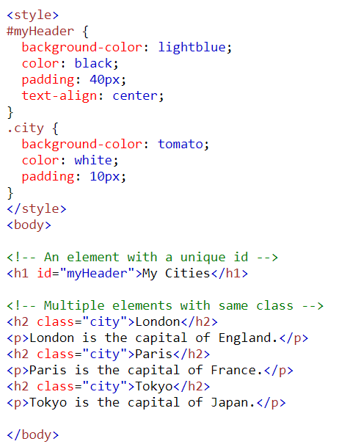

Result can be shown below:

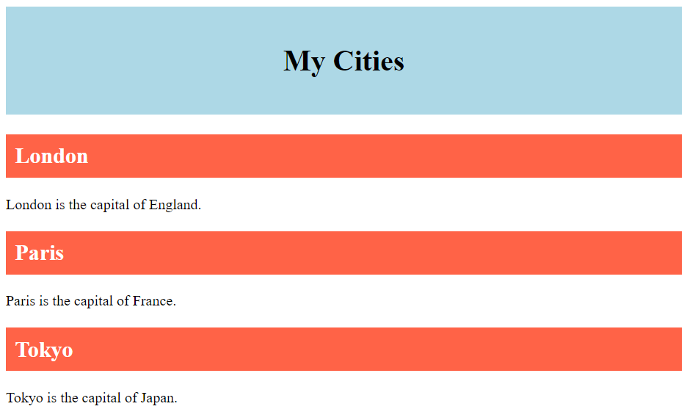

* **What are the various formatting tags in HTML?**
* The various formatting tags in HTML are as follows:

1. <b> - Bold text
2. <strong> - Important text
3. <i> - Italic text
4. <em> - Emphasized text
5. <mark> - Marked text
6. <small> - Smaller text
7. <del> - Deleted text
8. <ins> - Inserted text
9. <sub> - Subscript text
10. <sup> - Superscript text

* **How is Cell Padding different from Cell Spacing? With Example.**
* Cell padding is space between the cell edges and the cell content, while cell spacing is the space between each cell.

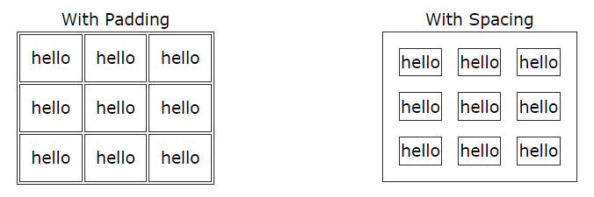Ex.

* **How can we club two or more rows or columns into a single row or column in an HTML table? With Example.**
* To club two or more rows or columns into a single row or column in an HTML table attributes called rowspan & colspan are used.

Ex. Colspan Attribute

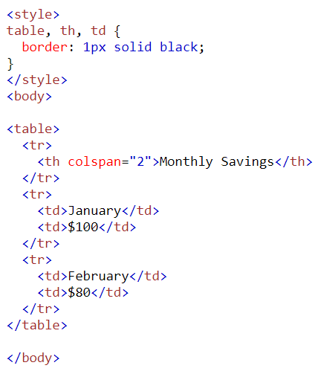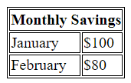

Rowspan Attribute

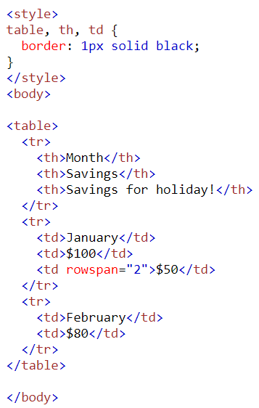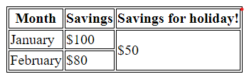

* **What is the difference between a block-level element and an inline element?**
* A block-level element always starts on a new line while an inline element does not start on a new line.
* A block-level element always takes up the full width available while an inline element only takes up as much width as necessary.
* **How to create a Hyperlink in HTML? With Example.**
* HTML links are hyperlinks. You can click on a link and jump to another document. When you move your mouse on the link, mouse arrow will change into a pointer.
* The HTML <a> tag defines a hyperlink. Its syntax is <a href=”#”>link text</a>.

Ex.

<!DOCTYPE html>

<html>

<body>

<a href="https://www.w3.org/">W3C</a>

<a href="https://www.google.com/">Google</a>

<a href="html_images.asp">HTML Images</a>

<a href="/css/default.asp">CSS Tutorial</a>

</body>

</html>

* **What is the use of an iframe tag? With Example.**
* Iframe tag is used to embed a document in HTML document.

Ex.

An example of embeded iframe tag of map is as follows:

**<iframe src="https://www.google.com/maps/embed?pb=!1m18!1m12!1m3!1d3672.723738782507!2d72.60635807509098!3d22.997184179191617!2m3!1f0!2f0!3f0!3m2!1i1024!2i768!4f13.1!3m3!1m2!1s0x395e85c2fc005927%3A0x918e69150ca1c935!2sTOPS%20Technologies!5e0!3m2!1sen!2sin!4v1704617805775!5m2!1sen!2sin" width="600" height="450" style="border:0;" allowfullscreen="" loading="lazy" referrerpolicy="no-referrer-when-downgrade"></iframe>**

Result: 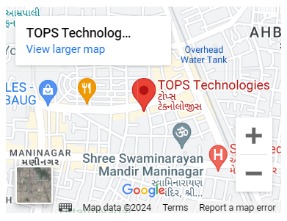

* **What is the use of a span tag? Explain with example?**
* Span tag is used to mark the part of the text or document. It can be manipulated with class or id attribute in the style sheet.

Ex. HTML code:

<p>My mother has <span style="color:blue;font-weight:bold">blue</span> eyes and my father has <span style="color:darkolivegreen;font-weight:bold">dark green</span> eyes.</p>

Result: 

* **How to insert a picture into a background image of a web page? With Example.**
* Background-image property in style sheet is used to insert a picture picture in background.

Ex.

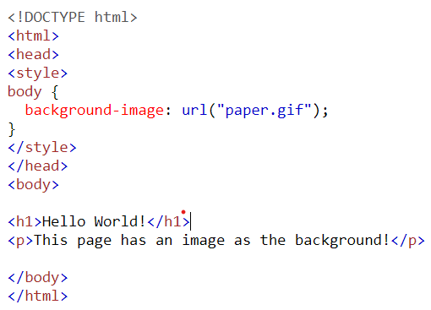



* **How are active links different from normal links?**
* Active links are those links which are already visited their color changes after they are visited, while normal links are links which are there on page and have not been clicked yet.
* **What are the different tags to separate sections of text?**
* To separate sections of text different tags are as follows:

1. <br> - It is used to separate the text in different line. It breaks the line and starts the following text in new line.
2. <p> - It is used to witr paragraph
3. <blockquote> - It is used to define large uoted sections.

* **What is SVG?**
* SVG stands for Scalable Vector Graphics.
* SVG is used to define vector-based graphics for the web.
* Every element and every attribute in SVG files can be animated.
* **What is difference between HTML and XHTML?**
* XHTML stands for E**X**tensible **H**yper**T**ext **M**arkup **L**anguage.
* HTML stands for **H**yper**T**ext **M**arkup **L**anguage.
* The min difference between XHTML & HTML is the syntax and structure.
* XHTML is a stricter, more XML-based version of HTML.
* XHTML is HTML defined as an XML application.
* **What are logical and physical tags in HTML?**
* To provide visual appearance to the text physical tags are used. Like making text **Bold**, *Italic*, Underlined, etc. the logical tags are used.
* Logical tags are used to add some logical and sementic value to the text. Like defining abbreviation of text, defining acronym, etc.
* **Create below example using only HTML tags without CSS.**
* GitHub link for html file of Table:

[**https://github.com/Avdheshpatel01/ASSIGNMENTS_TOPS/tree/main/HTML/Module_3_TABLE**](https://github.com/Avdheshpatel01/ASSIGNMENTS_TOPS/tree/main/HTML/Module_3_TABLE)

